IMPORTANCE OF COMPUTER ARCHITECTURE

COMPUTER ARCHITECTURE is a set of rules and methods that describe the functionality, organization, and implementation of computer systems. It defines how a system performs operations and executes instructions, serving as the blueprint for building and understanding computers.

Computer architecture is divided into sub-divisions which are :-
- Instruction Set Architecture (ISA) − Defines the interface between software and hardware. It specifies the instructions a processor can execute, data types, registers, memory addressing modes, and interrupt handling. The ISA acts as a contract between software programmers and hardware designers.
- Microarchitecture − Describes the internal design and implementation of a processor. It defines how the ISA instructions are executed using components like ALU, control unit, cache, and pipelines. Different processors can have the same ISA but different microarchitectures.
- System Design − Encompasses the overall computer system including processors, memory hierarchy, I/O devices, interconnection networks, and system-level features like virtualization and multiprocessing support.

Structure of Computer Architecture :-
A computer system consists of three fundamental components connected through a system bus as shown in the figure below

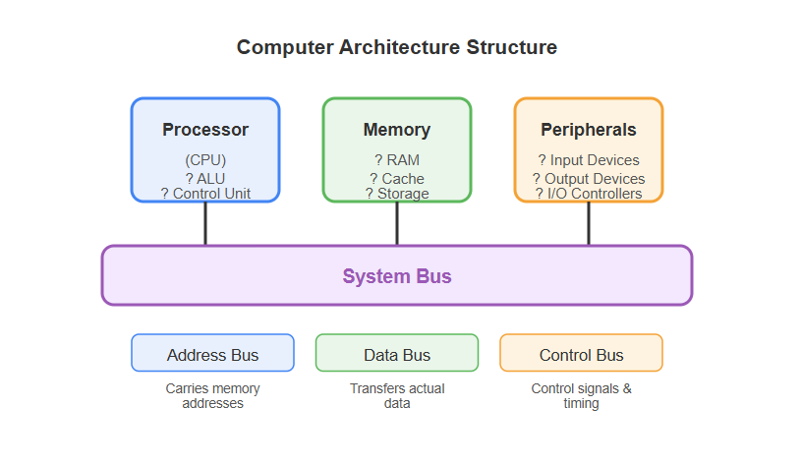

- Processor (CPU) − The central processing unit that executes instructions, performs calculations, and controls system operations.
- Memory − Stores data and instructions temporarily (RAM) or permanently (storage devices) for the processor to access.
- Peripherals − Input/output devices and their controllers that allow interaction with the external world.
The system bus connects these components and consists of three parts
- Address Bus − Carries memory addresses to specify data locations
- Data Bus − Transfers actual data between components
- Control Bus − Carries control signals and timing information

IMPORTANCE IN SOFTWARE DEVELOPMENT
Computer architecture is crucial for software developers to optimize code performance, manage memory efficiently, and utilize hardware capabilities like parallel processing. It bridges high-level code and hardware, assisting in debugging, improving system responsiveness, and making informed decisions about data structures and algorithms, ultimately leading to faster, more robust applications.
Here are the key points of importance in Software development :-
- Performance Optimization: Knowledge of pipelining, caching, and branch prediction allows developers to write code that minimizes latency and maximizes throughput, particularly for performance-intensive applications.
- Efficient Memory Management: Understanding memory hierarchies (registers, cache, RAM) helps in writing cache-friendly code that reduces cache misses and improves data access speeds.
- Leveraging Parallelism: Understanding multi-core processors and parallel instruction sets are essential for developing concurrent software that utilizes modern CPU capabilities.
- Debugging and Troubleshooting: A deep understanding of how processors execute instructions and handle interrupts enables developers to diagnose complex bugs and system-level issues.
- Hardware-Software Interaction: It provides insight into the Instruction Set Architecture (ISA), enabling developers to understand how high-level languages are translated into machine code, assisting in low-level programming and driver development.

BASIC TERMINOLOGY
Here are some basic terminology used in software development :-
- Program :- Basic instructions written for a computer to perform a task
- Software :- A collection of programs,data and related document.
- Application :- Software designed for end users.
- System Software :- Software that manages hardwares (example-windows,linux)

Software development process :- The process of building a software.This process contains
- SDLC(Software development life cycle) :-
- Planning – To plan for the whole process.
- Requirement analysis – Things required to build and develop(for the whole process).
- Design – Design the whole process according to the requirements.
- Development – Develop the whole software according to the design made previously.
- Testing – Thoroughly test the software to find any faults made in the previous processes and fix it.
- Deployment – After making sure no faults are there deploy the software into the market for the users.
- Maintenance – Is deployment enough?-NO,but should maintain the software is very important after deploying it.

CENTRAL PROCESSING UNIT(CPU)

A CPU is, essentially, the active brain of the computer. The CPU is the invisible manager inside the computer where data input is transformed into information output. It stores and executes program instructions through its vast networks of circuitry. Like the human brain, the CPU can multitask. This means it is also the part of the computer that simultaneously regulates the computer’s internal functions, oversees power consumption, allocates computing resources and interfaces with various apps, programs and networks.

COMPONENTS AND FUNCTIONS OF CPU

A CPU comprises several key components that process data and run instructions. The main components of a CPU are given next :-
- Control unit - The control unit manages instruction processing and coordinates data flow within the CPU and between other computer components. It has an instruction decoder component that interprets the instructions fetched from memory and converts them into micro-operations that the CPU can run. The control unit directs other CPU components to perform required operations.

- Registers :-
- Registers are small, high-speed memory storage locations within the CPU. They hold data that the CPU is currently working on and facilitate quick access to data. CPUs have several types of registers, like these:
- General-purpose registers that hold operational data
- Instruction registers that hold the current instruction being processed
- A program counter that holds the memory address of the next instruction to be fetched
- Registers provide faster access times than other memory levels like RAM or cache memory.

- ALU
- The arithmetic logic unit (ALU) performs basic arithmetic operations (addition, subtraction, multiplication, and division) and logical operations (AND, OR, and NOT) on data. It receives data from registers within the CPU, processes it based on the instructions from the control unit, and produces the result.

- Memory management unit
- Depending on the CPU architecture, there might be a separate bus interface unit or memory management unit. These components handle memory-related tasks, such as managing the CPU and RAM interaction. It also handles cache memory—a small and fast memory unit located within the CPU—and virtual memory that the CPU requires for data processing.

FUNCTIONS OF CPU :-
- Instruction Handling (Fetch-Decode-Execute Cycle): The CPU fetches instructions from RAM, decodes them, and executes them to perform tasks, a process repeated constantly.
- Data Processing: It handles arithmetic operations (addition, subtraction) and logical operations (comparing data) using the ALU (Arithmetic Logic Unit).
- Control Flow: The Control Unit (CU) coordinates data movement between the processor, memory, and peripheral devices, directing the flow of information.
- Input/Output Management: The CPU manages interaction with peripherals (keyboard, mouse, screen), translating user input into actions.
- Managing Memory: It manages temporary data storage in registers and cache during processing, ensuring fast access to data.

Basically a CPU is primarily responsible for executing instructions provided by software programs.

HOW A CPU EXECUTES INSTRUCTIONS

A CPU processes instructions through a repetitive, high-speed fetch-decode-execute-store cycle, billions of times per second. It fetches instruction binary code from RAM, decodes it into control signals, executes operations using the Arithmetic Logic Unit (ALU), and stores results, guided by a system clock and managed by the Control Unit (CU).
- Fetch : The CPU, specifically the Control Unit, uses the Program Counter (PC) to find and retrieve the next instruction from the system's memory (RAM).
- Decode :The Instruction Decoder analyzes the fetched binary instruction to determine what operation (e.g., ADD, MOVE) is required and fetches any needed data.
- Execute: The CPU carries out the action, often involving the ALU for mathematical or logical calculations.
- Store : The final results of the execution are written back to memory or stored in a register for future use.

UI Layer (Presentation Layer)
The UI (User Interface) layer is the topmost part of the application that users see and interact with. It is responsible for displaying data and capturing user inputs (like button clicks or form entries).Components are Web browsers, mobile app screens or GUI’s.(Angular,react)
API Layer (Application/Logic Layer)
The API layer acts as the intermediary "brain" of the application, connecting the UI to the data storage. It processes the business logic—the specific rules of the application, such as calculating discounts, validating user credentials, or processing orders.(Springboot,fast api and Django).
Database Layer
The Database layer is the bottommost tier where all application data is permanently stored and managed. It handles the storage, retrieval, and structural organization of data.Components are Relational databases like MySQL or PostgreSQL, and NoSQL databases like MongoDB.

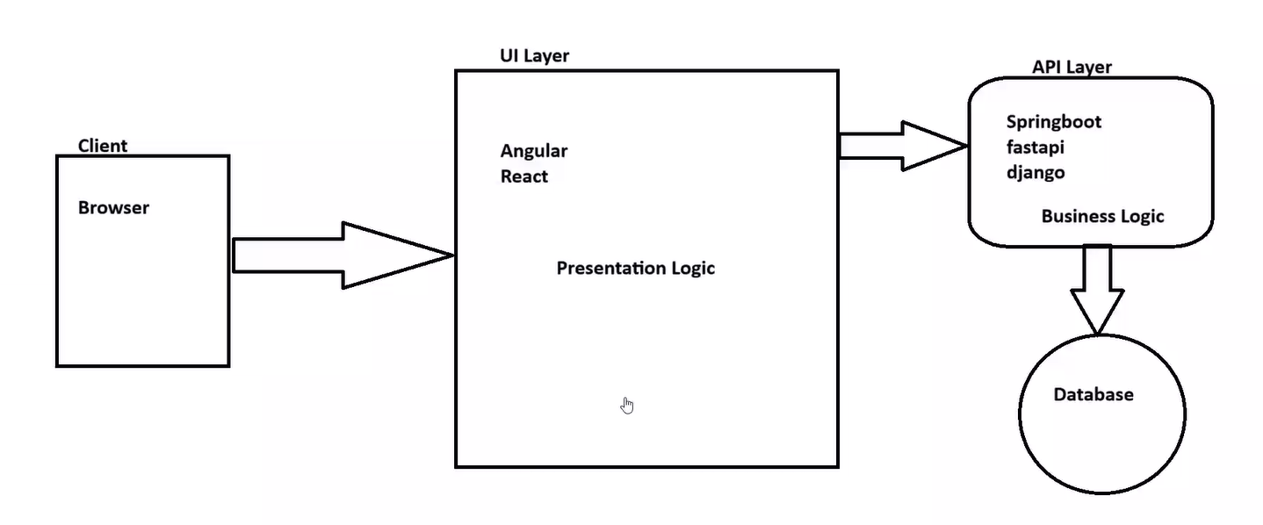

CACHE
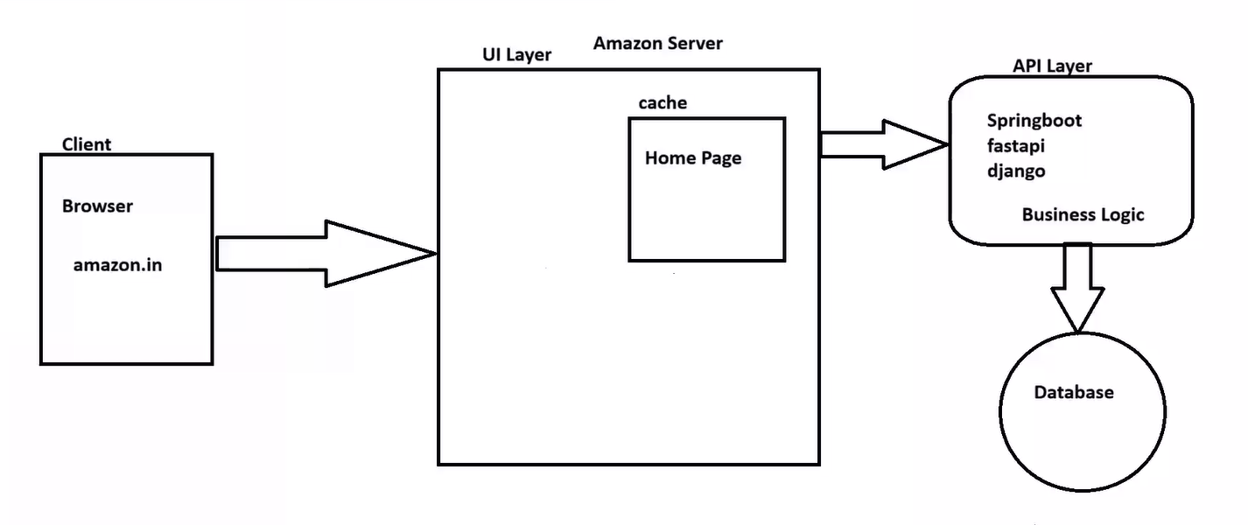
Caching is the technique of storing frequently accessed data in a temporary, high-speed storage layer (RAM) to serve requests faster, reducing the load on primary databases and speeding up performance.
Taking the Amazon homepage as an example, imagine millions of users browsing simultaneously. If every user triggered a database query for top deals or product images, the system would crash. Caching allows Amazon to serve static content (images, layouts) and popular dynamic content (best-seller lists) from memory rather than querying the database every time.
Benefits for Amazon by cache:
- Speed: Near-instant loading of pages. (improved user experience).
- Scalability: Handling millions of concurrent users.
- Cost Efficiency: Fewer database queries mean cheaper infrastructure costs.

INPUT/OUTPUT SYSTEMS

Input and output (I/O) systems act as the communication bridge between a computer's CPU and external devices, enabling data entry (input) and result presentation (output). Input devices (keyboard, mouse,etc) send data into the system for processing, while output devices (monitor, printer,etc) display or produce the results.
How I/O Systems Work:
- Data Flow: Input devices send raw information to the computer for processing.
- Processing: The CPU processes the data based on user input or instructions.
- Output Display: The processed information is sent back to an output device for the user.
- Interface: Devices connect to the system via ports (e.g., USB, HDMI) or wireless technologies (e.g., Bluetooth, Wi-Fi).

Common I/O Devices:
- Input: Keyboard, Mouse, Microphone, Webcam, Scanner.
- Output: Monitor, Printer, Speaker, Projector.

OVERVIEW OF I/O SYSTEMS

Difference between Hardware and software I/0 :- Hardware I/O refers to physical components such as hard drives, CPUs and memory cards while software I/O describes how these physical components interact with each other via programs or applications. Hardware devices are necessary for sending and receiving data while software provides a way for those devices to communicate cleverly and efficiently with each other.
I/O affects overall system performance because it involves reading, writing and transferring data across components and peripherals which can consume valuable resources like RAM or CPU cycles. Furthermore, certain types of I/O are more taxing on system resources than others; for example, streaming video requires more bandwidth than sending an email. Therefore, understanding how much data will be transferred by a particular operation is important for optimizing system speeds and preventing lag times.

Relationship between I/O and memory :- I/O and memory have a close relationship because they rely on each other in order to properly utilize a computer's processing power. Input devices transmit data to the computer's memory while output devices read information from that same memory in order to display it. Without adequate amounts of both input and output, a computer would not be able to effectively communicate with its users or other systems.

COMMUNICATION BETWEEN CPU,MEMORY AND I/O DEVICES
Communication between the CPU, memory, and I/O devices occurs via a shared system bus (data, address, control). The CPU initiates transfers, using I/O interfaces to synchronize speed differences between high-speed processors and slower peripherals. Data is exchanged using techniques like programmed I/O, interrupts, or direct memory access (DMA).

- System Bus: The highway connecting components. The CPU uses the Address Bus to select devices, Data Bus for moving data, and Control Bus to manage read/write actions.
- I/O Interface: Acts as a bridge between the CPU and peripherals, managing data formatting and signal synchronization.
- Memory-Mapped I/O: Peripheral devices are assigned distinct memory addresses; the CPU treats them like memory locations.

UNDERSTANDING COMPUTER NETWORKING

A computer network connects computing devices (nodes) using wired or wireless media to share resources, data, and applications. It relies on components like routers and switches, operating via standardized protocols to exchange information. Key types include LANs (local) and WANs (wide area), underpinning internet access and cloud services.
Core Components of a Network
- Nodes/Devices: Computers, servers, printers, and smartphones that act as end-users.
- Networking Devices: Components that manage traffic, such as routers (connect networks), switches (connect devices on a network), and hubs.
- Transmission Media: Physical cables (fiber optic, copper) or wireless radio waves (Wi-Fi) used to transfer data.
- Protocols: Sets of rules (like TCP/IP, HTTP) that define how data is formatted and transmitted.

WHAT IS NETWORKING

A computer network is a system of interconnected computing devices (nodes) that exchange data and share resources, such as printers, files, or internet access, using wired or wireless transmission media. These devices follow predefined rules called protocols to ensure accurate, secure communication, forming the backbone of digital infrastructure.
Common Network Types
- LAN (Local Area Network): Connects devices in a small area like an office or home.
- WAN (Wide Area Network): Spans large geographical areas, such as the Internet.
- MAN (Metropolitan Area Network): Connects networks across a city.
- PAN (Personal Area Network): A network for one person's devices, like Bluetooth.

WHAT ARE BASIC NETWORKING CONCEPTS

Computer networking connects computing devices (nodes) to share resources and data via wired or wireless media. Fundamental components include devices (routers, switches), protocols (TCP/IP), and addressing (IP/MAC). Key concepts involve network types (LAN/WAN), security (firewalls), and data transmission techniques.
- TCP/IP (Transmission Control Protocol/Internet Protocol): The standard protocol suite for internet communication.
- DHCP (Dynamic Host Configuration Protocol): Automatically assigns IP addresses to devices.
- DNS (Domain Name System): Translates human-readable names (e.g., www.example.com) to IP addresses.
- OSI Model: A 7-layer theoretical framework explaining network communication.

NETWORK MODELS AND PROTOCOLS

Key Network Models
- OSI (Open Systems Interconnection) Model (7 Layers): A theoretical standard consisting of Physical, Data Link, Network, Transport, Session, Presentation, and Application layers.
- TCP/IP Model (4 Layers): The practical protocol suite used for the Internet, comprising the Network Access, Internet, Transport, and Application layers.

Protocols
Key Protocols by OSI Layer
- Application Layer (7): Provides network services to applications (HTTP, HTTPS, FTP, SMTP, DNS).
- Presentation Layer (6): Translates, encrypts, and formats data (SSL/TLS).
- Session Layer (5): Manages sessions between devices.
- Transport Layer (4): Ensures reliable (TCP) or fast (UDP) data delivery.
- Network Layer (3): Handles routing and logical addressing (IP, ICMP, ARP).
- Data Link Layer (2): Manages physical addressing (MAC) and node-to-node transfer (Ethernet, Wi-Fi).
- Physical Layer (1): Transmits raw bits over physical media (cables, connectors).
Core Protocol Functions
- Addressing/Routing: IP (Internet Protocol) routes data packets across networks.
- Reliability: TCP (Transmission Control Protocol) manages data segmenting and reliable delivery.
- Speed: UDP (User Datagram Protocol) provides low-latency transmission for streaming.
- Network Access: Ethernet and Wi-Fi facilitate hardware-level connections.
- Automatic Configuration: DHCP (Dynamic Host Configuration Protocol) assigns IP addresses automatically.

SOFTWARE DEVELOPMENT LIFE CYCLE

The Software Development Life Cycle (SDLC) is a structured framework used by teams to build high-quality software at low cost and in minimal time. It ensures compliance, enhances efficiency, and aligns deliverables with stakeholder expectations.

Key Stages of SDLC:
- Planning & Requirement Analysis: Defining the scope, goals, risks, and resources.
- Design: Creating the architectural blueprint (system design, user interface).
- Development: Coding and building the software based on design specs.
- Testing: Identifying bugs and ensuring quality via unit, integration, and system testing.
- Deployment: Releasing the product into the production environment.
- Maintenance: Providing ongoing support, updates, and fixing issues.
This software development life cycle is never ending loop/process. That’s why it is called as “CYCLE”

WHAT IS PYTHON
Python is a popular, high-level, interpreted programming language. Key features and uses of Python include:
- Simple & Readable: It uses indentation instead of curly braces, making it easy to learn and maintain.
- Versatile: Used for server-side web development, data analysis, AI, machine learning, and automation.
- Interpreted & Dynamic: Code is executed line-by-line, allowing for fast debugging and rapid prototyping.
- Open Source & Portable: Free to use, and runs on all major platforms (Windows, macOS, Linux).
- Large Ecosystem: It boasts an extensive standard library and numerous third-party packages.

ADVANTAGES OF PYTHON

- Readability and Simplicity: Python's syntax is intuitive and closely mirrors the English language, making it exceptionally easy for beginners to learn. It uses indentation to define code blocks, which enforces a clean and readable coding style.
- Improved productivity: Python allows developers to achieve more with fewer lines of code compared to languages like Java or C++. Its interpreted nature enables rapid testing and debugging by executing code line-by-line.
- Portability and integration: Python is cross-platform, meaning code written on one operating system (Windows, macOS, Linux) can run on others with minimal modification. It also integrates easily with other languages like C, C++, and Java.
- Scalability: : While often used for small scripts, Python is powerful enough to handle large-scale enterprise solutions and is utilized by major companies like Google, Netflix, and NASA and many more.

HOW IS PYTHON USEFUL IN AI AND ML WORLD
5 Scenarios:-
Python is considered the premier language for the AI and ML world because its simple syntax allows developers to focus on complex algorithm logic rather than technical coding hurdles.

- Data Preprocessing & Manipulation: Using libraries like Pandas and NumPy to clean, transform, and analyze large, messy datasets, making them suitable for machine learning training.
- Computer Vision Applications: Building AI systems that analyze images or video using OpenCV or TensorFlow for facial recognition, object detection in autonomous vehicles, or medical image analysis.
- Natural Language Processing (NLP): Creating chatbots, sentiment analysis tools, or automated text summarizers using libraries like NLTK, SpaCy, or Hugging Face Transformers to interpret human language.
- Predictive Analytics (Machine Learning): Implementing algorithms such as regression, classification, or clustering using Scikit-learn to forecast stock prices, identify fraudulent transactions, or personalize recommendations.
- Deep Learning & Neural Networks: Training complex, multi-layered models for advanced AI tasks (e.g., generative AI, speech recognition) using PyTorch or TensorFlow.

